Additional Things To Do In and Around Beautiful Eau Claire
Are you bringing a spouse/significant other who is looking for something to do while you’re stuck sitting in seminars? If craft beer or wine tasting is their thing, how about a brewery or winery hop? Eau Claire and the Chippewa Falls area has a nice offering of both.
Breweries
The Brewing Projekt
1807 North Oxford Avenue, Eau Claire
Lazy Monk Brewery
97 West Madison Street, Eau Claire
Modicum Brewery
3732 Spooner Avenue, Altoona
K-Point Brewery
4212 Southtowne Drive, Eau Claire
Lucette Brewing Company
910 Hudson Road, Menomonie
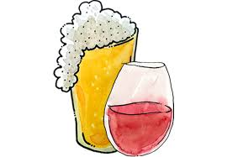
Wineries
Infinity Wine and Spirits
3460 Mall Drive, Eau Claire
River Bend Vineyard and Winery
10439 33rd Avenue, Chippewa Falls
Autumn Harvest Winery and Orchard

19947 Co Hwy J, Chippewa Falls
NO DESIGNATED DRIVER? NO WORRIES!
Hop on the bus with Bus Bros. Tour Company!
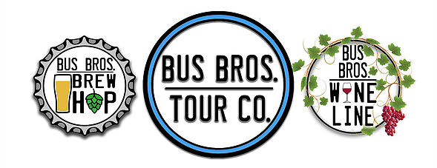
www.busbrostourco.com
715-533-9396

If FOOD is more of your thing, how about a Food Walking Tour? Brand new in 2018, Chippewa Valley Tours helps you discover Eau Claire’s downtown confluence district as you taste foods and beverages from independently owned and operated establishments and learn about Eau Claire’s rich history. Book in advance. Tours fill up fast!
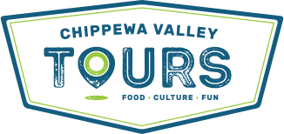
www.chippewavalleytours.com
715-256-7898

