Do you love language?
Are you looking for an exciting and challenging career?
Do you enjoy working with technology?
Court reporters are experts at converting
speech into readable text through the
application of realtime technology and
their skills are sought in many settings:
in courts and deposition rooms; in meetings,
conferences, conventions and business
settings; and in television stations, where
reporters caption live news and sports
telecasts for people who are deaf or
If you would like more information about court reporting, please ask the bailiff to contact the court reporter.

wicourtreporters.org

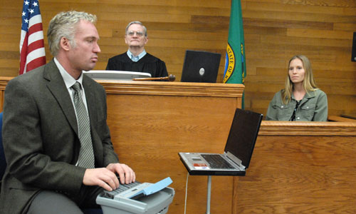
hard of hearing.

Choose court reporting as a career. Your potential is unlimited.

